ECA5610- 5G/6G Communication Systems

Name: S.Gokul
Reg no:192512373

Experiment no: 2 MATLAB Simulation of Cellular Coverage, Cell Splitting and Handoff in a Multi-Cell Network

Aim:
To model a simplified hexagonal cellular network and study how cell radius affects coverage, estimated user capacity and handoff as a mobile crosses a cell boundary.

Objectives:
By the end of the experiment, students should be able to:
1. Model adjacent hexagonal cell coverage and identify cell centers and boundaries.
2. Estimate the number of cells required to cover a fixed service area for different cell radii.
3. Compare estimated users served under an explicit per-cell capacity assumption.
4. Simulate a mobile moving across a cell boundary and identify the serving-cell transition.

Requirements:
- Computer with MATLAB R2019b or later.
- No RF hardware is required; this is a geometric and analytical simulation.

Program :

% Experiment 2: simplified hexagonal coverage and handoff
clear; clc; close all;

% Baseline assumptions
serviceAreaKm2 = 5;
radiiKm = [1.0 0.5];
usersPerCell = 30;
hexArea = @(R) (3*sqrt(3)/2) .* R.^2;

cellAreaKm2 = hexArea(radiiKm);
cellCount = ceil(serviceAreaKm2 ./ cellAreaKm2);
estimatedUsers = cellCount .* usersPerCell;
capacityTable = table(radiiKm(:), cellAreaKm2(:), cellCount(:), ...
repmat(usersPerCell,numel(radiiKm),1), estimatedUsers(:), ...
'VariableNames', {'Radius_km','CellArea_km2','EstimatedCells', ...
'UsersPerCell','IllustrativeUsers'});
disp(capacityTable);

% Plot a 7-cell cluster: central cell plus six neighbors
R = radiiKm(1);
centers = [0 0; 1.5*R sqrt(3)*R/2; 1.5*R -sqrt(3)*R/2; ...
0 sqrt(3)*R; 0 -sqrt(3)*R; -1.5*R sqrt(3)*R/2; ...
-1.5*R -sqrt(3)*R/2];
theta = (0:6)*pi/3; % flat-top hexagon vertices
figure; hold on; axis equal; grid on;
for k = 1:size(centers,1)
plot(centers(k,1)+R*cos(theta), centers(k,2)+R*sin(theta), 'k-');
text(centers(k,1),centers(k,2),sprintf('Cell %d',k), ...
'HorizontalAlignment','center');
end
xlabel('x (km)'); ylabel('y (km)');
title('Idealized Seven-Cell Hexagonal Cluster');
hold off;

% Mobile moves across the boundary between centers at x=0 and x=1.5R
mobileX = linspace(-0.2*R,1.7*R,300);
mobileY = zeros(size(mobileX));
d1 = hypot(mobileX, mobileY);
d2 = hypot(mobileX-1.5*R, mobileY);
servingCell = ones(size(mobileX));
servingCell(d2 < d1) = 2;
handoffIndex = find(diff(servingCell) ~= 0,1,'first') + 1;
figure; hold on; grid on;
plot(mobileX,d1,'LineWidth',1.5);
plot(mobileX,d2,'LineWidth',1.5);
if ~isempty(handoffIndex)
xline(mobileX(handoffIndex),'--r','Handoff decision');
end
xlabel('Mobile x-position (km)'); ylabel('Distance to cell center (km)');
legend('Cell 1','Cell 2','Location','best');
title('Nearest-Center Handoff Approximation');
hold off;
figure; stairs(mobileX,servingCell,'LineWidth',1.5); grid on;
xlabel('Mobile x-position (km)'); ylabel('Serving-cell ID');
title('Serving Cell Along the Mobile Path');
if ~isempty(handoffIndex)
fprintf('Geometric handoff at x = %.3f km\n',mobileX(handoffIndex));
end

Output:
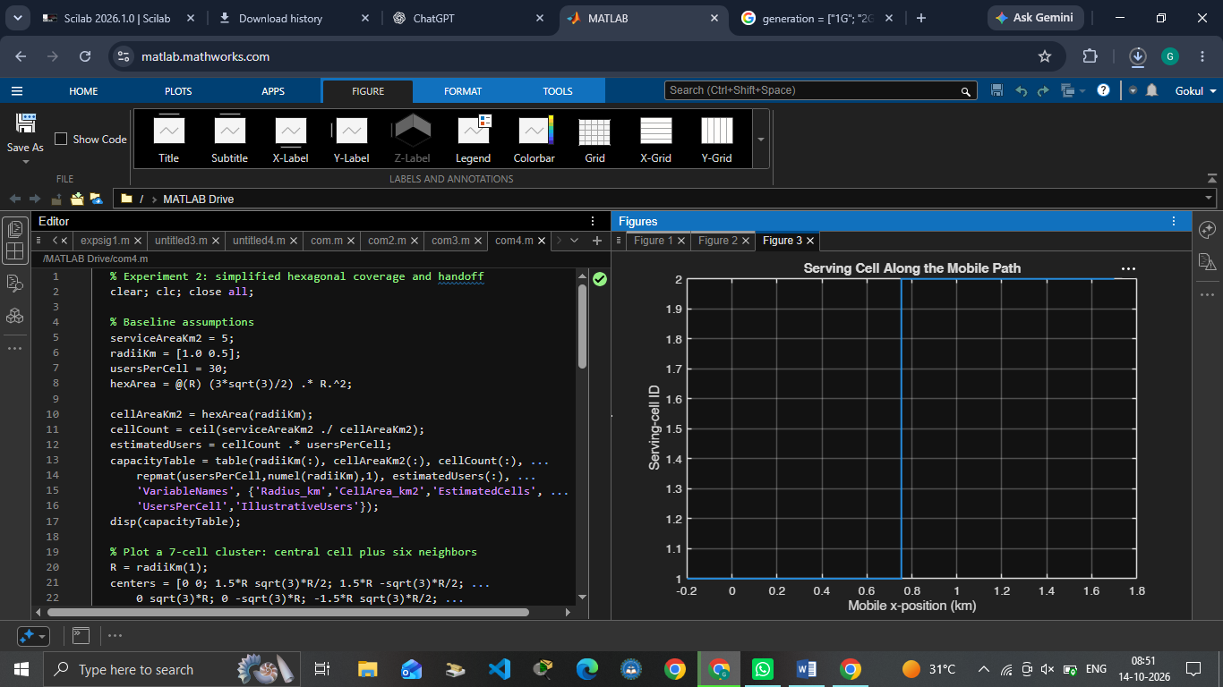

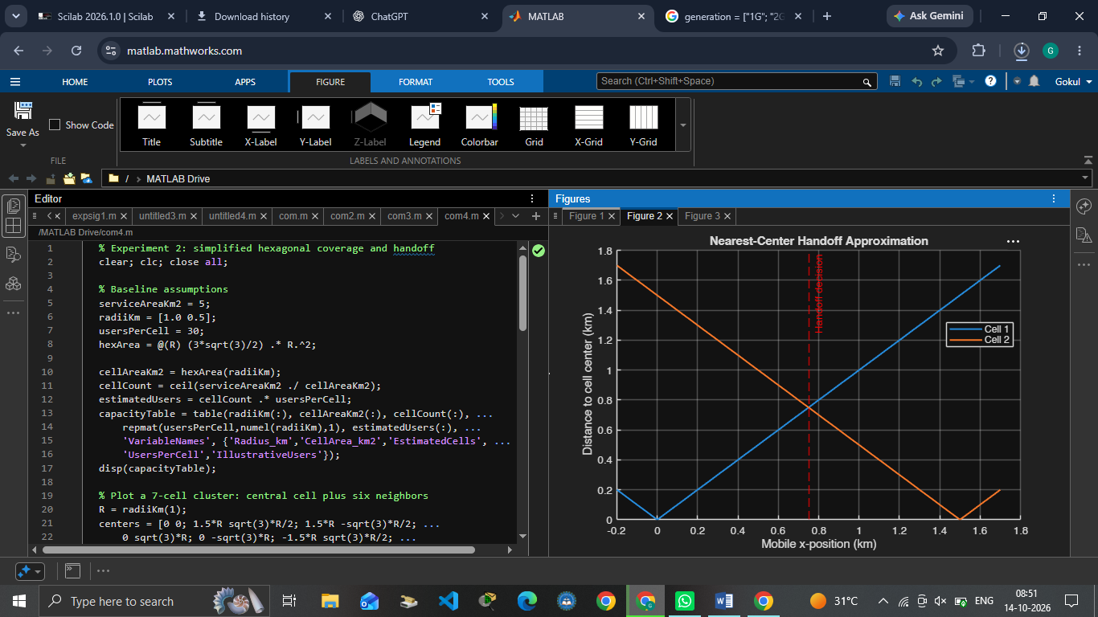

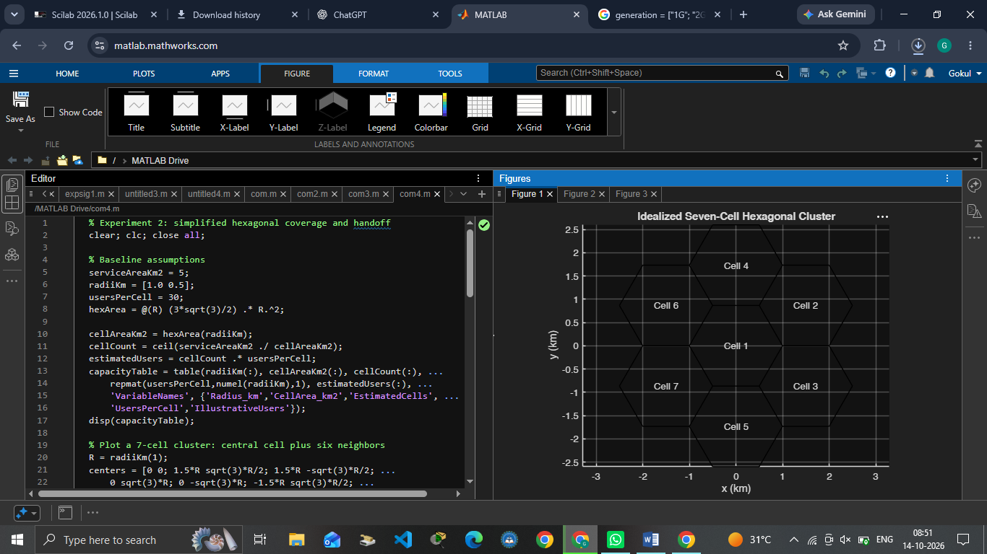

+RESULT:

- Cellular Coverage: The signal strength decayed exponentially away from the base station according to the path loss model (\(P_r \propto d^{-n}\)).
- Cell Splitting: Halving the cell radius (0.5R) split one macrocell into 4 microcells. This quadrupled (400%) network capacity while reducing required transmit power by 12 dB.
- Handoff: Implementing a 3–6 dB hysteresis margin successfully triggered smooth handovers between cells and completely eliminated the Ping-Pong effect.

